# Coding corals

Lee Wee Ru Skye

U1640324D

***A computational project studying the resilience of deep sea corals in North Pacific region in face of climate change:*** *Individual report generated to conclusively analyse deep sea coral resilience through Matlab coding.*

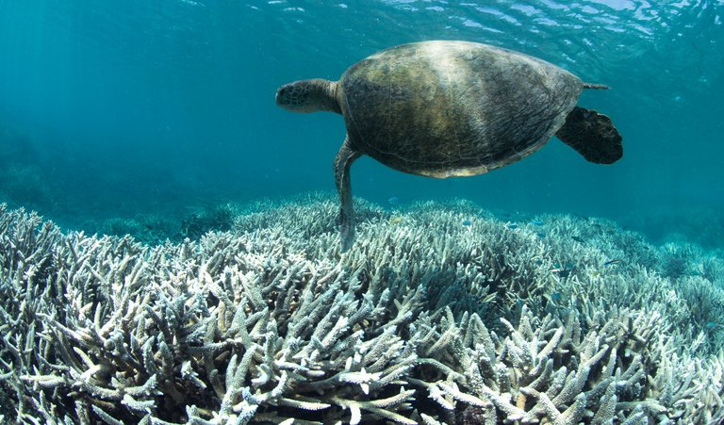

1. **Introduction**

**Background:** The phenomenon of global coral bleaching events due to global warming and El Nino first occurred in 1998. Since then, two more severe and prolonged events occurred in 2010 and 2014 respectively (NOAA, 2017). Coral bleaching occurs under stress conditions where the corals expel their symbiotic algae and consequentially turning white (NOAA, 2017). Furthermore, high frequency of bleaching events in the 20th century decreases coral recovery period before they experience stress conditions again (NOAA, 2017). This potentially reduces the corals’ resilience towards stress conditions.

**Hypothesis:** We hypothesize that climate change is the main factor undermining the corals’ resilience and different coral species display differing degrees of resilience towards stress conditions.

**Scientific question:** How resilient are North Pacific deep-sea[1] corals in face of climate change?

1. **Regional Setting & Time Frame**

The Pacific Ocean homes the most diverse species of deep sea corals in the world (NOAA, 2017). From which, we chose the North Pacific Region (Figure 1 in Appendix) due to the congregation of large Marine Protected Areas (MPAs) and National Marine Sanctuaries (NMS) (Mpatlas, 2017). This is to limit anthropogenic factors contributing to coral bleaching and better investigate the contribution of climate change parameters. The time frame decided upon was 2000 to 2015 as the phenomenon of coral bleaching events has intensified since year 2000 till now (IPCC, 2007) and reliable datasets used contain the stipulated time period.

1. **Datasets**

An investigation of the correlation between climate change indicators and coral resilience requires the following data sets (Table 2 in Appendix). The dataset highlighted in blue was mainly used by Skye for coding and analysis of individual coral species resilience to worsening climate change.

|  |  |  |  |  |  |
| --- | --- | --- | --- | --- | --- |
| **Datasets** | **Description** | **Deliverables** | **Format** | **Source** | **Limitations** |
| 1.NOAA Deep Sea Coral Database | Coral records and distribution sorted annually | 1.Graph of total coral records in North Pacific over time  2.Plot of coral distribution (distinct by colours) in North Pacific  3.Histogram of coral species per year  4.Graph of individual species count against time | Comma-seperated values  (.csv) | NOAA 2015 | 1.There was an abundance of ‘-999’ values found in ‘individual count’ of each coral species: prevent an accurate summation of coral count for each species  2. Unusually low number of coral records for pre-2000 years: set time frame for analysis to begin from year 2000  3. The coral species data was not consistent in certain years for all the 17 coral species, only 7 were found to be continuous within our time frame of year 2000 to 2015 |

1. **Assumptions**

Firstly, due to the constrains of the NOAA Deep Sea Coral Database returning ‘-999’ values in the ‘individual count’ of each coral species with no further explanation, we had to use the number of coral records as a proxy for the coral population. This returns the minimum number of corals annually. Secondly, while recognising the complexity of climate change, we had to assume that the 7 climate change parameters used were adequately indicative of worsening climate change. Lastly, we assumed that the congregation of MPAs and NSCs allow us to exclude anthropogenic influences on coral resilience and population.

1. **Matlab Techniques**

Skye was mainly responsible for coding and analysis of individual coral species in the North Pacific region. For which, she plotted and animated individual coral species map coded in color together with a histogram for individual coral species count (Refer to Figure 5 in Appendix). Together with Ze Ming, they plotted individual coral species count against time for further analysis (Figure 6 & Table 3 in Appendix). Skye also plotted a linear best fit line for clarity in the trend of Ocean Heat Content (Figure 3 in Appendix). Lastly, she created functions, ***for*** loops and organised data to plot the climate change indicators more efficiently. For more detailed description of contribution, refer to Table 1 of Appendix.

|  |  |  |
| --- | --- | --- |
| **Coral Species Distribution. csv** | | |
|  | **Challenges** | **Solutions** |
| **1.** | The code to load and convert the data to be imported was long and had to be repeated several times. | Skye created a function to load the data efficiently and hence cleaning/shortening the script. |
| **2.** | The .csv files had some difficulty when being imported, Reynold and Nicholas ultimately imported it as a structure which cannot be used easily and efficiently. | Skye and Ze Ming worked together to convert the structure into cell array using ***struct2cell*** from which data was easily extracted and used. |
| **3.** | The .csv files were downloaded by years. Some of the files by year were corrupted to include 3 empty columns which could not be deleted. Thus, the corrupted and uncorrupted files must be loaded differently. | Skye and Ze Ming created 2 ***for*** loops together to loop through the year files for simplicity and efficiency.  Nicholas provided the list of corrupted and uncorrupted years as he encountered this problem previously in his own script. |
| **4.** | Only North Pacific Ocean was of interest hence there is a need to constrain our plotted map to the lat, long of the North Pacific and extract out the lat, long from the data file for plotting the coral species distribution | -As the lat, long of the North Pacific region was not readily available online, Skye and Ze Ming had to figure out the coordinates of the region of interest themselves.  -These coordinates were used in ***axesm*** to constrain the region of the map plotted in ***MapLatLimit*** and ***MapLonLimit***.  -From which they downloaded data files to be used constrained by the following region.  -As the lat, long provided by the .csv file was a cell after conversion, they further converted it into a double using ***cell2mat*** to be used for plotting in ***plotm***. |
| **5.** | To show the spatial distribution of the individual coral species across the world map, there was a need to return the indexes the individual corals and for the individual species to be plotted in different colour.  - To define the marker colour and ***DisplayName***, a cell cannot be included in ***plotm*** but requires conversion to a string.  -An individual coral species could not be defined by an individual colour, it kept changing colour in different years which defied the purpose of plotting different coral species in different colour. | Done by Skye & Ze Ming:  -For efficiency, a ***for*** loop was created to loop through the entire length of all coral species (Tcoralname) and using ***strmatch*** to find the possible matches between the Tcoralname and the uniqued coral species vernacular names (Vname) for that particular year, where the indexes of such matches were returned.  Done by Skye:  - Using ***if*** loop to only plot the coral species distribution when the index returned during the ***strmatch*** is not empty.  -The marker colors (markerc) allocated to each individual species had to be defined into a variable as cell array. Each colour was delicately defined individually using [R:G:B] as there was 17coral species while the usual color ‘name’ options were limited.  - The strings that defined the marker color and ***DisplayName*** in ***plotm*** were in cell arrays and was converted into character arrays using ‘char’. |
| **6.** | The ‘year’ cell array extracted could not be ***unique***d as it is a cell array. | Skye and Ze Ming converted the contents of the multidimensional cell array into a single matrix using ***cell2mat***. This returns the unique values of ‘years’ using ***unique*** command. |
| **7.** | The coral species files are annual hence to extract all the individual species data by time series is difficult.  To plot individual coral species count against a time series, the count of corals at each year must be known but this is not easily found within the raw data. | Skye and Ze Ming used a ***for*** loop through the uniqued species and ***strmatch*** to match the uniqued coral names with the entire list of coral names.  - The returned indexes were used to extract year and species from the entire list of corals. These were then concatenated together.  - With a ***for*** loop through the years, the ***find*** function is used to return the indexes of the particular years for that species.  - By comparing the 2 strings of a particular unique species and that species in the total coral string using ***strcmp*** which returns 1 (true) if the two are identical and 0 (false) otherwise. Summing up the instances of 1 returned will give us the count of that particular species in that particular year. |
| **8.** | The years of the coralspeciesdistribution data were in 2 different ***for*** loop, hence creating a ‘.gif’ to animate them was difficult. | Skye with assistance from Reyno:  Managed to create the animation in each ***for*** loop and combined the frames accordingly afterwards. See code in Figure 7 of appendix. |

1. **Discussion**

The correlation of the 7 climate change indicators to coral population across the time series of 2000 to 2015 shows a negative correlation for 5 of indicators (SST, SST anomaly, DHW, Hotspots, dissolved carbon) and positive correlation for pH. This shows that there is a correlation between climate change enforcing stress conditions on North Pacific coral population. Greater reduction of coral population, in the absence of anthropogenic factors, can be attributed to higher coral death.

Based on our analysis on the impact of El Nino events to coral bleaching, with prolonged and intensified El Nino the corals will suffer longer under worsening stress conditions and have shorter periods of recovery (Gaskill, 2017). Less recovery time signifies the higher possibility of bleached corals death. This potentially reduces the resilience of corals to impending stress conditions (Reefresilience, 2017).

For the resilience of individual North Pacific corals species, 7 species out of 17 were analysed as they were present across the stipulated time series. These species are then analysed based on the change in count in years of recent Global Bleaching Event (2010-2011 & 2014-2015). Out of these 7 species, soft corals and demosponge are the least resilient as their count decrease in both year, signifying deaths. Black coral and sponge increase in count for 2010 but decrease in 2014, showing that they may be resilient to the stress conditions in 2010 but not for 2014 as they might have reached their thresholds. Glass sponge and Gorgonian corals are resilient as they have adapted from the species’ deaths in 2010 to survive the 2014 stress conditions. The sea pen[2] (Science, 2017) is the most resilient as it increased in count for both mass bleaching events.

1. **Limitations**

Firstly, our time frame was only limited to 2015 due to lack of current data in this field. This constrained the competence of our analysis as the 2014 mass bleaching event continues to date. Secondly, as all our datasets were analysed based on their annual fluctuations, there was no consideration of seasonal, monthly, weekly or even daily fluctuations in the North Pacific Ocean. Thirdly, due to the complexity of climate change indicators, both direct and indirect, to coral bleaching, we could not account for each interaction. For example, La Nina was found to create equally stressful cold conditions to the corals that threaten their resilience (Zhang et al., 2017), yet inadequate research and data in this field prevents us from further analysis. Thirdly, only coral species with continuous time frame of 2000 to 2015 were analysed, which excluded at least 10 other coral species from resilience analysis due to data constrains. Lastly, as sponges were included in the NOAA deep sea coral database, we analysed their resilience along with coral species. While sponges belong to another animal phylum and have differences, sponges and corals are within the same kingdom and both function significantly as coral reef builders (Diffen, 2017).

1. **Conclusion**

Analysis from correlating climate change indicators to coral population across 2000 to 2015 had led us to infer that with worsening climate change (thermal and ocean acidification stresses) there was higher coral bleaching leading to higher coral death (in absolute numbers). This signifies the undermining of coral resilience in the North Pacific region with worsening climate change. From which, there was drastic reduction in coral population numbers in year 2010 and 2014 which were recorded as global mass bleaching events. From analysing the coral records of each individual coral species, we found differing degrees of resilience during these events. Further scientific result can be conducted to investigate the complexity of climate change indicators, especially the interaction of enhanced ENSO on coral bleaching and death. With more competent data recordings, the North Pacific coral species resilience can be better analysed over a longer timeframe.

# **references**

1. Diffen.com. (2017). *Corals vs Sponges - Difference and Comparison | Diffen*. [online] Available at: https://www.diffen.com/difference/Corals_vs_Sponges [Accessed 10 Nov. 2017].
2. Gaskill, M. (2017). *Coral bleaching goes from bad to worse*.
3. IPCC, 2007: Climate Change 2007: Impacts, Adaptation and Vulnerability. Contribution of Working Group II to the Fourth Assessment Report of the Intergovernmental Panel on Climate Change, M.L. Parry, O.F. Canziani, J.P. Palutikof, P.J. van der Linden and C.E. Hanson, Eds., Cambridge University Press, Cambridge, UK, 976pp.
4. Marine Conservation Institute. (2017). *National Marine Sanctuaries » Marine Conservation Institute*. [online] Available at: https://marine-conservation.org/what-we-do/program-areas/mpas/national-marine-sanctuaries/ [Accessed 9 Nov. 2017].
5. Mpatlas.org. (2017). *MPAtlas » Home*. [online] Available at: http://mpatlas.org/ [Accessed 9 Nov. 2017].
6. Noaa.gov. (2017). *El Niño prolongs longest global coral bleaching event | National Oceanic and Atmospheric Administration*. [online] Available at: http://www.noaa.gov/media-release/el-ni-o-prolongs-longest-global-coral-bleaching-event [Accessed 9 Nov. 2017].
7. Oceanservice.noaa.gov. (2017). *What is coral bleaching?*. [online] Available at: https://oceanservice.noaa.gov/facts/coral_bleach.html [Accessed 9 Nov. 2017].
8. Oceanservice.noaa.gov. (2017). *What ocean basin has the most corals?*. [online] Available at: https://oceanservice.noaa.gov/facts/most_coral.html [Accessed 9 Nov. 2017].
9. Science, L. (2017). *Colorful Sea Pens Decorate Ocean Floor*. [online] Live Science. Available at: https://www.livescience.com/15435-sea-pens-corals-marine-deep-water.html [Accessed 10 Nov. 2017].
10. Reefresilience.org. (2017). *Resistance, Tolerance and Recovery | Reef Resilience*. [online] Available at: http://www.reefresilience.org/coral-reefs/stressors/bleaching/resistance-tolerance-and-recovery/ [Accessed 10 Nov. 2017].
11. Zhang, N., Feng, M., Hendon, H., Hobday, A. and Zinke, J. (2017). Opposite polarities of ENSO drive distinct patterns of coral bleaching potentials in the southeast Indian Ocean. *Scientific Reports*, 7(1).

# **appendix**

**Regional setting**

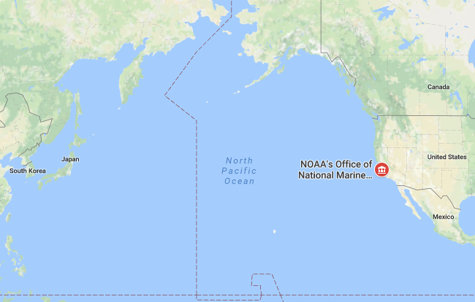

Figure 1: Location Map showing the North Pacific Ocean which is the region of interest in this project.

**Work Distribution**

All group members were involved in sourcing for the datasets they will be working with and coding for. While there was an overlap of work contribution due to assistance provided to each other, the main work allocation was as below:

* Nicholas and Kai Ting worked together to plot, correlate and analyse the climate change indicators with coral population used for Preliminary Analysis.
* Reynold was responsible for plotting, animating and analysing the various bleaching datasets for Secondary Analysis.
* Skye and Zeming worked together to plot, calculate and analyse the individual coral species count, distribution and resilience in face of worsening climate change for Final Analysis.

|  |  |
| --- | --- |
| Nicholas | 1. Sourcing data for ocean heat content 2. Obtaining yearly coral population data 3. Find the years where there is decrease in coral records 4. Calculating yearly sea surface temperature, sea surface temperature anomaly, dissolved inorganic carbon and pH levels 5. Plotting the above datasets, along with DHW and hotspot data into figures and analysing them 6. Creating functions to read the coral and bleaching dataset (with help from Reynold and Ze Ming) 7. Final analysis of project |
| Skye | 1. Sourcing & downloading North Pacific deep-sea coral distribution data 2. Calculating and plotting individual coral species records across time 3. Plotting yearly coral distribution by color 4. Plotting histograms of coral species by year 5. Animated the figures in 3 & 4 6. Created a function and creating ***for*** loops to make ‘Climate change indicator script’ more efficient 7. Plotting linear best-fit line for OHC 8. Assisted in organising data to plot SST, SST anomaly, DHW Hotspot data in North Pacific Region on a map. 9. Final analysis of project |
| Kai Ting | 1. Obtaining yearly coral population data 2. Calculating the correlation between coral records and yearly sea surface temperature (SST), SST anomaly, dissolved inorganic carbon (nDIC), pH levels 3. Plotting the above datasets into figures and analysing them 4. Final analysis |
| Ze Ming | 1. Sourcing for DHW, SST, SST anomaly, Hotspot data in North Pacific region 2. Source for CO2 and pH data in North Pacific Region 3. Calculating and plotting individual coral species records across time 4. Data conversion and extraction for coral species distribution 5. Calculating yearly DHW and hotspot data 6. Plotting histogram to show annual coral distribution among different species 7. Final analysis |
| Reynold | 1. Analysing degree of bleaching in North Pacific by plotting stations with recorded bleaching severity code on a map. 2. Analysing interpolated probability of bleaching occurrence between 1985 to 2010. 3. Helped Ze Ming plot SST, SST anomaly, DHW, Hotspot data on a map obtained from NOAA Coral Reef Watch Virtual Stations for each year. 4. Assisted in reading the dissolved inorganic carbon and pH levels data into MATLAB 5. Assisted in loading data of coral distribution into MATLAB. 6. Analysing the final figures and drawing conclusions. 7. Assisted in creating animation for yearly coral distribution and histograms 8. Final analysis |

Table 1: Table showing the detailed description of individual contribution and distribution of the project among group members.

|  |  |  |  |  |
| --- | --- | --- | --- | --- |
| **Datasets** | **Description** | **Deliverables** | **Format/Type** | **Source** |
| 2.Ocean Heat Content | OHC recorded by 3 North Pacific stations | 1.Plot of OHC against years  2.Linear BestFit Line  3.Mean of OHC  4.Correlation between coral records & OHC | Textfile  (.txt) | NOAA, CSIRO, MRI/JMA |
| 3. Annual composites of twice weekly 50km satellite coral bleaching monitoring products | Sea Surface Temperature (SST) max, SST anomaly min, mean Bleaching Hotspots & locations, Degree Heating Week (DHW) max | Plot of SST, SST anomaly, Hotspot, DHW data over time on a map | Hierarchical  data format  (.hdf) | NOAA Satellite and Information Service |
| 4. Climate change indicators:  SST, SSTa, DHW, Hotspots | Different parameters of climate change recorded at various stations in North Pacific Ocean | 1.Individual plots SST, SST anomaly, Bleaching Hotspots and their mean against time  2.Correlation between mean of each dataset and coral records | Text file  (.txt) | NOAA Coral Reef Watch Virtual Stations |
| 5.Hawaii Ocean Time-series (HOT) surface CO2 system data product | Mean seawater salinity normalized dissolved inorganic carbon & Mean seawater pH annually | 1.Individual plots of mean dissolved inorganic carbon & Mean seawater pH against time  2.Correlation between mean and coral records | Textfile  (.txt) | HOT program |
| 6. Bleaching Severity Code | Severity Code classified as:  0 – no bleaching  1 – mild  2 – moderate  3 – severe bleaching | Map showing areas with recorded severity code over time | Excel Spreadsheet file  (.xls) | Observational Bleaching Database |

Table 2: Table continued from ‘3. Datasets’ section. The above datasets are used in the Matlab project for various areas of analysis.

**Preliminary Data Analysis**

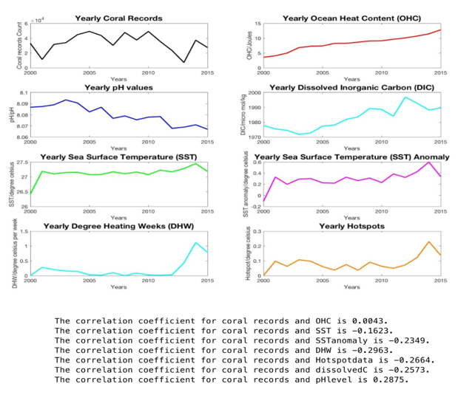

Figure 2: Plots of the seven climate parameters (SST, SST anomaly, Ocean heat content, Oceanic pH, dissolved inorganic Carbon, Yearly Hotspots, DHW) and North Pacific coral population against time. Below are statements indicating the correlation coefficient of each climate parameter to coral population.

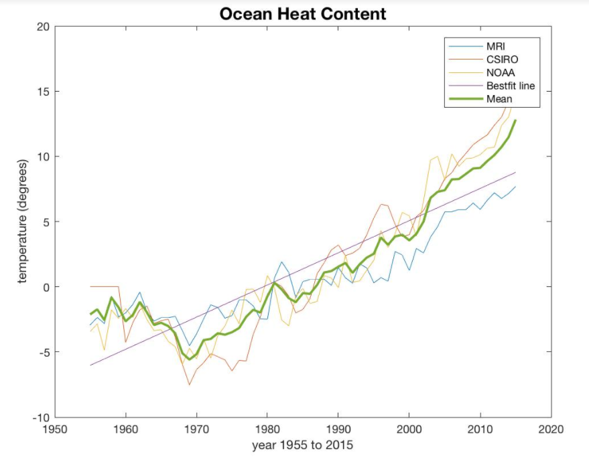

Figure 3: Plot of Ocean Heat Content against time with a linear bestfit line and mean OHC for the 3 stations used.

**Secondary analysis**

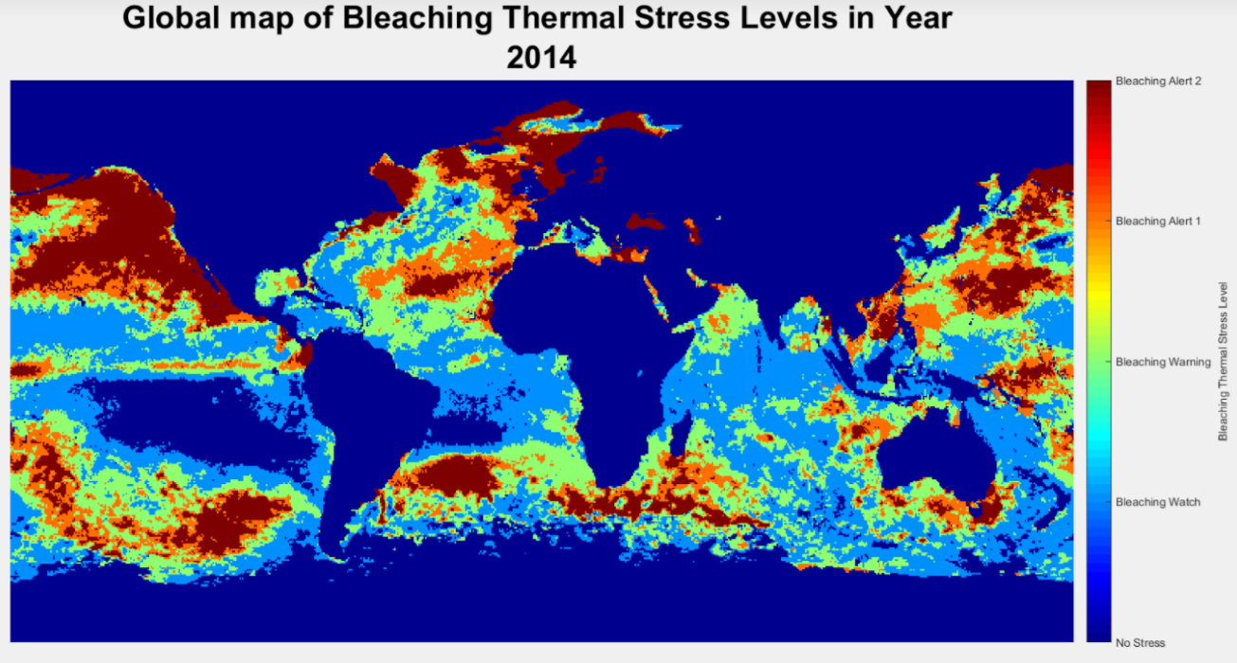

Figure 4: Animation displaying bleaching alert warning. From this map, global mass bleaching events in 2010 and 2014-2015 can be identified by the drastic increase in red bleaching alert 2 areas.

**Final Data Analysis**

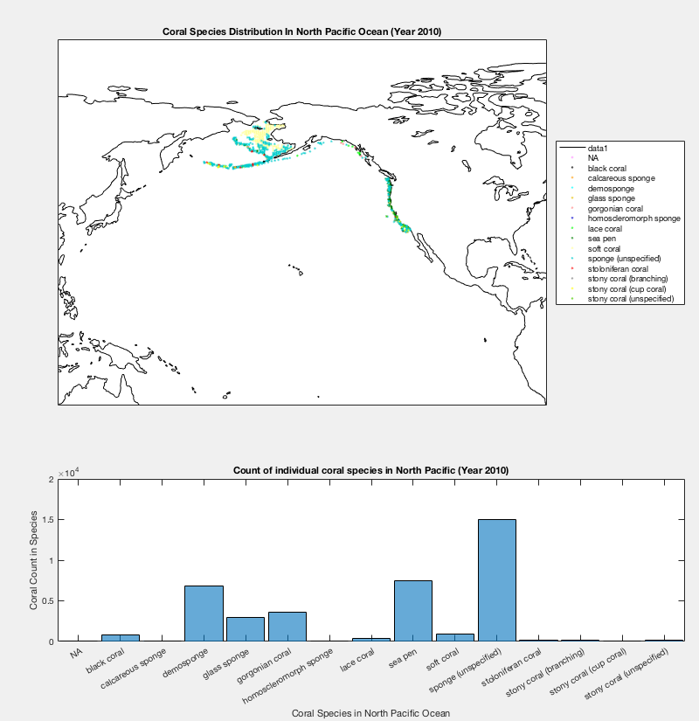

Figure 5: Animation of North Pacific Ocean with individual coral species distribution coded in different colours above a histogram counting the individual coral species annually from 1982 – 2015.

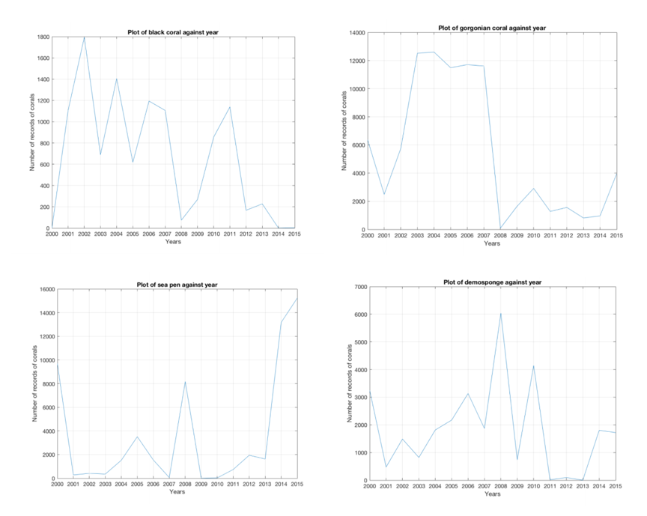

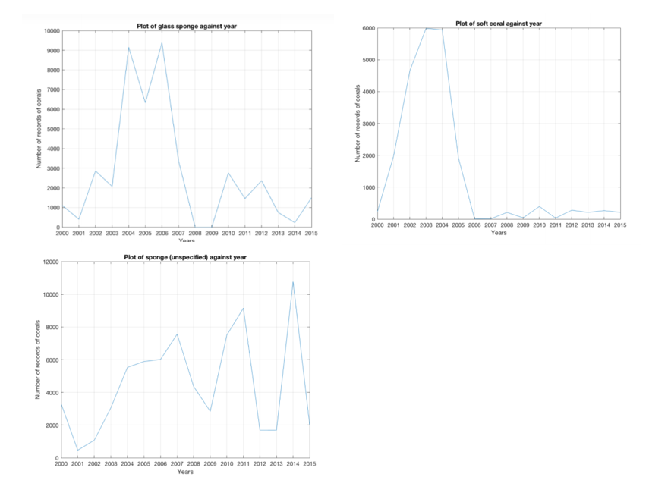

Figure 6: Plots of individual coral species chosen against time (Year 2000 – 2014). From these plots, analysis of the resilience of the coral species based on the increment or reduction in numbers during the 2010 and 2014 mass bleaching events.

|  |  |  |  |
| --- | --- | --- | --- |
| **Individual Coral Species** | **Year 2010 - 2011** | **Year 2014 - 2015** | **Overall resilience** |
| Soft Coral | ↓ | ↓ | Least resilient |
| Black Coral | ↑ | ↓ | Threshold reached (Not adapted) |
| Glass Sponge | ↓ | ↑ | Resilient  (Adapted) |
| Sea Pen | ↑ | ↑ | Most resilient |
| Gorgonian coral | ↓ | ↑ | Resilient  (Adapted) |
| Demosponge | ↓ | ↓ | Least resilient |
| Sponge | ↑ | ↓ | Threshold reached (Not adapted) |

Table 3: Table showing the reduction and increment in coral numbers for each of the seven chosen coral species during years 2010 and 2014. Based on this analysis, the corals are then categorised into differing degrees of resilience.

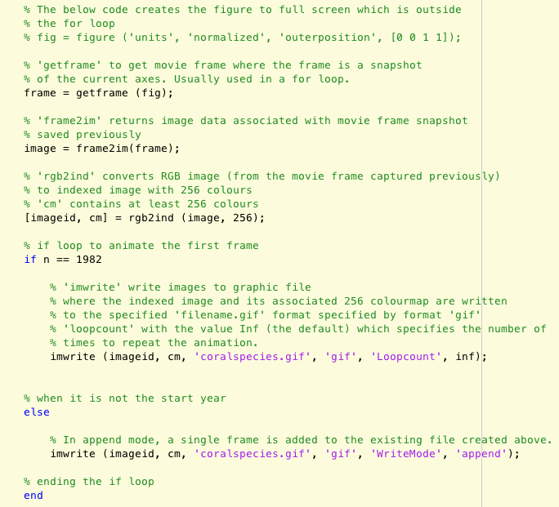

Figure 7: Matlab code showing how to animate the plots of coral distribution and histogram across a time frame in a for loop.

1. Deep-sea corals are defined as an assemblage of hexacorals, octocorals and calcified hydroid families in the phylum Cnidaria with species known to grow deeper than 200m. They are known as cold-water or deep-sea corals.
2. Sea pens are octocorals, grouped together with soft corals, named for the eight stinging tentacles used to capture plankton for food.